Heron Park Tennis Club Championships 2020
DOUBLES
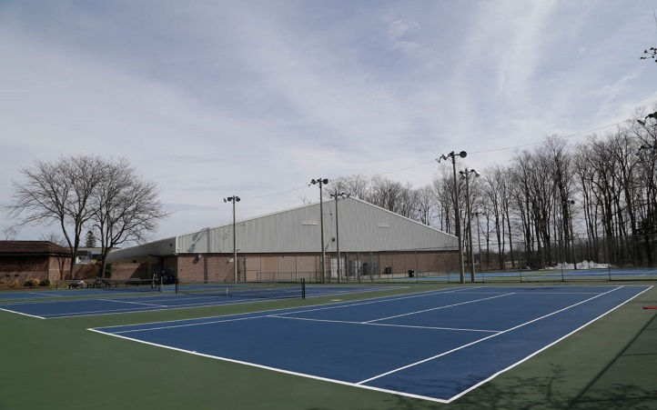
August 21-23, 2020
- Objective: To provide Heron Park Members with a safe way to play competitive doubles matches against other members and to determine who the Club Champion doubles players are for 2020! Comes with one full year of bragging rights!
- Schedule: All matches will be scheduled over the weekend of August 21-23 so please be available most of the weekend if you sign up.
- Events: Men’s Doubles, Ladies Doubles, Mixed Doubles
- Who Can Enter? This tournament is open to all Heron Park members regardless of age or skill level. Please try to find your own partners but if you want to sign up as a single-I can try to find you a partner.
- Cost: Free (must be a paid Heron Park member). Due to current COVID rules, everyone must bring their own can of balls for each match.
- Format: Dependent on number of entries. Round robin format if there are 3-4 entries in a category, and single elimination draw with an optional consolation if there are 5 or more entries in a category. Matches will follow typical Ontario Tennis Association (OTA) rules and format (regular scoring, best 2 out of 3 sets)
- Prizes: Trophies and prizes will be presented to the champions and finalists!
- To enter: Please contact tournament director Ian Winningham at ian.winningham45@gmail.com or text 647-331-9895. Please indicate which event you would like to enter. Entry Deadline: Wednesday August 19 at 11:59 pm. Entry is limited to the first 16 teams in each category so sign up as soon as possible! Draws will be made on Thursday August 20th and sent to participants so matches can be arranged.

